Hands-On Data Lab Implementation

1. Introduction
Data analysis is the process of collecting, organizing, processing, and interpreting data to obtain meaningful information. It helps in understanding patterns, identifying trends, and making informed decisions.
The purpose of this project, titled "Hands-On Data Lab Implementation," is to develop practical knowledge of data analysis using Python. Python is a widely used programming language in the field of data science because of its simplicity and powerful libraries.
In this project, a sample student performance dataset is used to demonstrate the basic concepts of data analysis. The dataset contains information about students, including their study hours, attendance, and examination marks.
The project includes data manipulation, data visualization, and basic statistical analysis. These activities help in understanding how raw data can be transformed into useful information.
This project provides practical experience in using Python and its data science libraries while developing essential analytical and programming skills.

2. Objective
The main objective of this project is to develop practical skills in data analysis using Python and its essential libraries.
The specific objectives of the project are:
- To set up a Python-based data analysis environment.
- To understand the basic concepts of data science and data analysis.
- To learn how to create and manipulate datasets using Pandas.
- To perform numerical calculations using NumPy.
- To explore datasets using descriptive statistics.
- To create meaningful visualizations using Matplotlib and Seaborn.
- To analyze relationships between different variables.
- To interpret analytical results and present findings in a structured report.
The project aims to improve programming knowledge, analytical thinking, and problem-solving abilities through practical exercises.

3. Tools and Technologies
The following tools and technologies are used in this project:
1. Python: Python is the main programming language used to perform data manipulation, calculations, and analysis.
2. Google Colab: Google Colab is a cloud-based platform that allows users to write and execute Python code without installing Python locally.
3. Jupyter Notebook: Jupyter Notebook provides an interactive environment where code, explanations, and results can be organized together.
4. Pandas: Pandas is a Python library used for data manipulation, data cleaning, and working with structured datasets.
5. NumPy: NumPy is used for numerical computations and mathematical operations.
6. Matplotlib: Matplotlib is a visualization library used to create graphs and charts.
7. Seaborn: Seaborn is used to create statistical visualizations and explore relationships between variables.
These tools provide an effective environment for performing basic data analysis and visualization.

4. Environment Setup
The data analysis environment was prepared using Google Colab, a cloud-based Python development platform.
Google Colab provides an interactive notebook environment that allows users to execute Python code without requiring a local installation of Python.
The following steps were performed to set up the environment:
- Opened Google Colab using a web browser.
- Created a new Python notebook.
- Imported the required Python libraries.
- Prepared a sample dataset for analysis.
- Executed Python code cells to verify that the environment was working correctly.
The following Python libraries were imported:
import pandas as pd
import numpy as np
import matplotlib.pyplot as plt
import seaborn as sns

print("Environment setup completed successfully")

5. Data Manipulation
Data manipulation is an important step in the data analysis process. It involves organizing, transforming, and processing data to make it suitable for analysis.
In this project, Pandas is used to create and manipulate a student performance dataset. The dataset contains five records with information about study hours, attendance, and examination marks.
The DataFrame structure is used to store the data in rows and columns. Functions such as head(), info(), and describe() are used to explore the dataset and understand its structure.
The average examination marks are calculated using the mean() function. The analysis shows that the average marks of the students in the sample dataset are 75.
This practical exercise demonstrates how Pandas can be used to organize data and perform basic calculations efficiently.

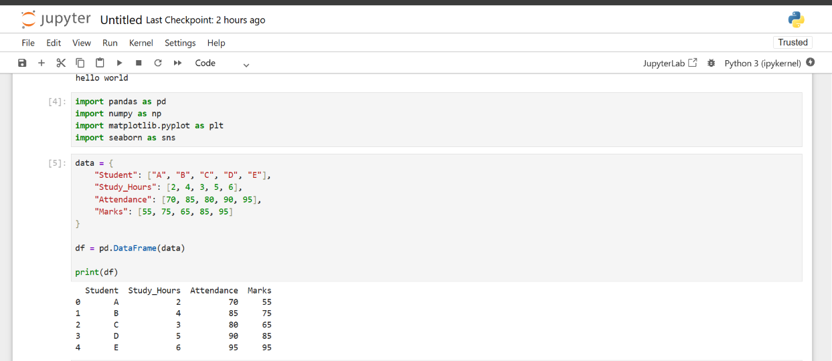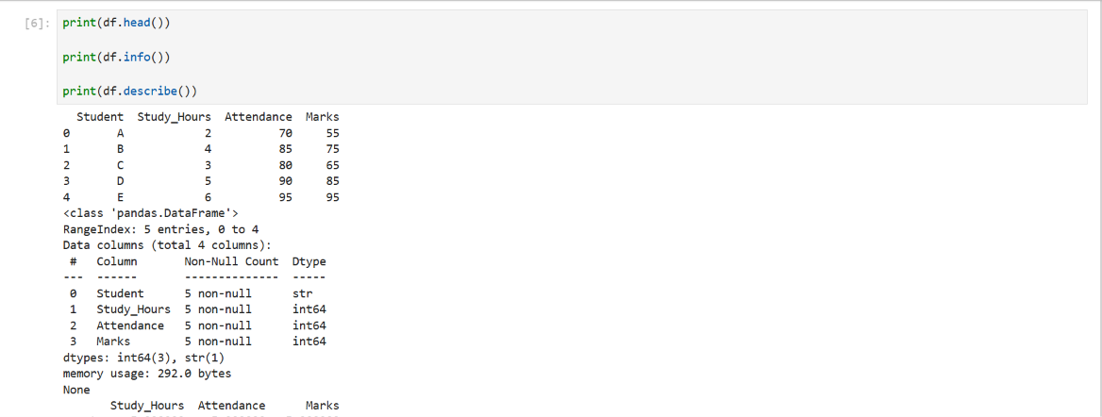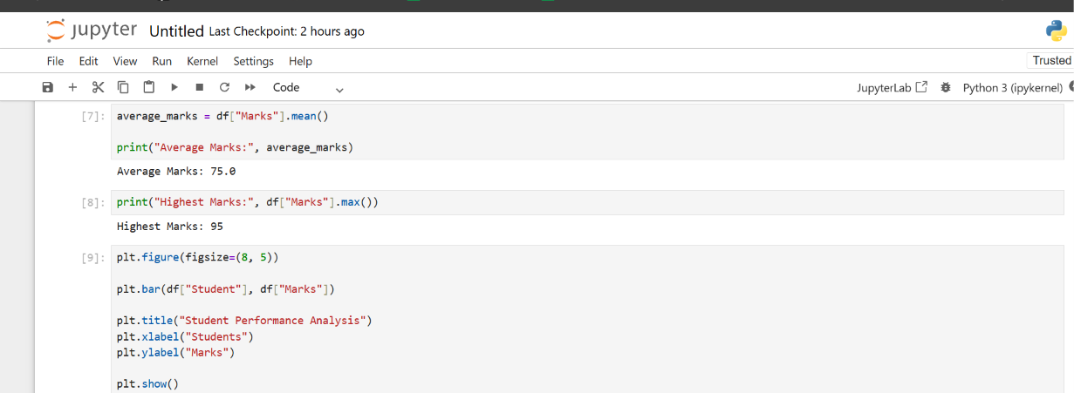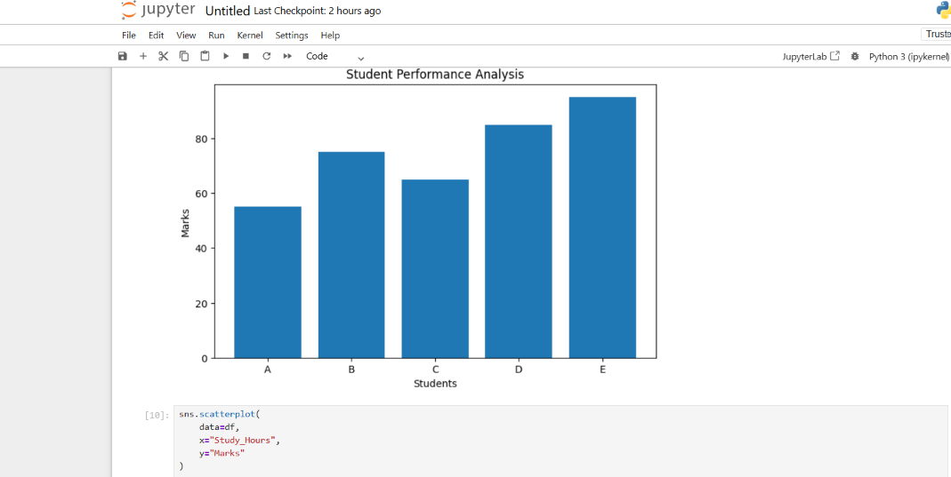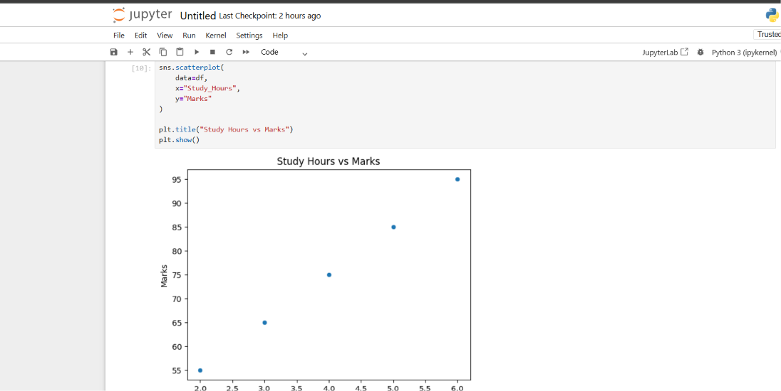6. Data Visualization
Data visualization is the graphical representation of data using charts and graphs. It helps in understanding complex information in a simple and meaningful way.
In this project, Matplotlib and Seaborn are used to visualize student performance data.
A bar chart is created to compare the examination marks of different students. This visualization helps identify the differences in student performance.
A scatter plot is also created to examine the relationship between study hours and examination marks. The plot provides a visual representation of how study hours are associated with student performance.
The visualizations make it easier to identify patterns and understand the dataset. They also demonstrate the importance of graphical representation in data analysis.

7. Data Analysis
Data analysis involves examining data to identify patterns, relationships, and useful information.
In this project, basic statistical analysis is performed on the student performance dataset using Python.
The average examination marks are calculated to understand the overall performance of the students. The highest marks are also identified to determine the maximum score in the dataset.
Correlation analysis is used to examine the relationship between study hours and examination marks. The correlation coefficient provides a numerical measure of the strength and direction of a linear relationship between two variables.
The sample dataset shows a positive relationship between study hours and examination marks. This indicates that students who studied for more hours generally achieved higher marks in the sample data.
However, the dataset contains only five students. Therefore, the results are used only for demonstrating basic analytical techniques and should not be considered a general conclusion about student performance.

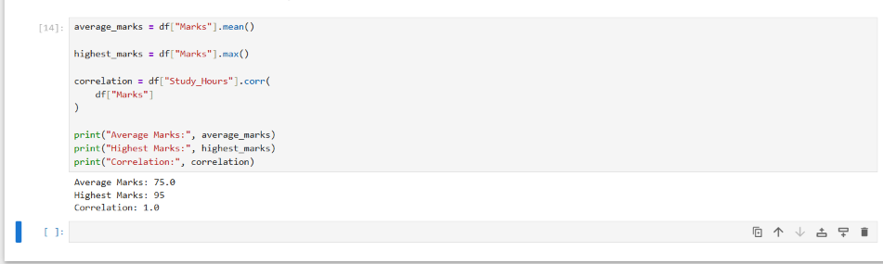8. Results and Conclusion
The Hands-On Data Lab Implementation project was completed using Python and its essential data science libraries.
The project provided practical experience in setting up a data analysis environment and working with structured datasets.
The following results were obtained from the sample student performance dataset:
- Total students analyzed: 5
- Average examination marks: 75
- Highest examination marks: 95
- Relationship between study hours and marks: Strong positive correlation in the sample dataset
Data manipulation techniques were successfully implemented using Pandas. Numerical calculations were performed using Python and NumPy. Graphical representations were created using Matplotlib and Seaborn.
The bar chart helped compare student marks, while the scatter plot provided a visual understanding of the relationship between study hours and examination marks.
The project demonstrated how Python can be used to organize, analyze, and visualize data efficiently.
In conclusion, this internship task helped develop practical knowledge of data analysis, data visualization, and statistical interpretation. It also improved programming skills and analytical thinking.
The project serves as a foundation for more advanced data science tasks involving larger datasets, data cleaning, statistical modeling, and machine learning.

